Worksheet No. – 01

Aim/Overview of the practical: The aim of the experiment is to create a worksheet with different data and apply the logical formulas on the data like IF Statement, Nested IF, AND, OR, NOT, IFERROR, SUMIF, AVERAGEIF, COUNTIF, and AVERAGEIF. These formulas allow you to add logic to your spreadsheet.
Objective: The objective of this experiment is to understand and apply various logical functions in Microsoft Excel for efficient data analysis and decision-making. It aims to create a worksheet with different types of data and use formulas such as IF, Nested IF, AND, OR, NOT, IFERROR, SUMIF, COUNTIF, and AVERAGEIF to perform conditional calculations, evaluate multiple criteria, handle errors, and summarize data accurately.

Procedure/Algorithm/Code
Procedure:
- Open Microsoft Excel and create a new worksheet.
- Enter the student data (Attendance and marks of 5 subjects).
- Format the worksheet with headings and borders.
- Apply the required formulas (IF, Nested IF, AND, OR, NOT, IFERROR, SUMIF, AVERAGEIF, and COUNTIF).
- Verify the calculated results.
- Save the worksheet.

IF FORMULA:
Definition:
The IF function checks whether a condition is TRUE or FALSE and returns one value if TRUE and another value if FALSE.
Condition:
Marks more than 35.
Formula:
=IF(B2>=35,"PASS","FAIL")

Sukhleen Kaur (25MCA20031)
25MCA-6 (B)

OUTPUT
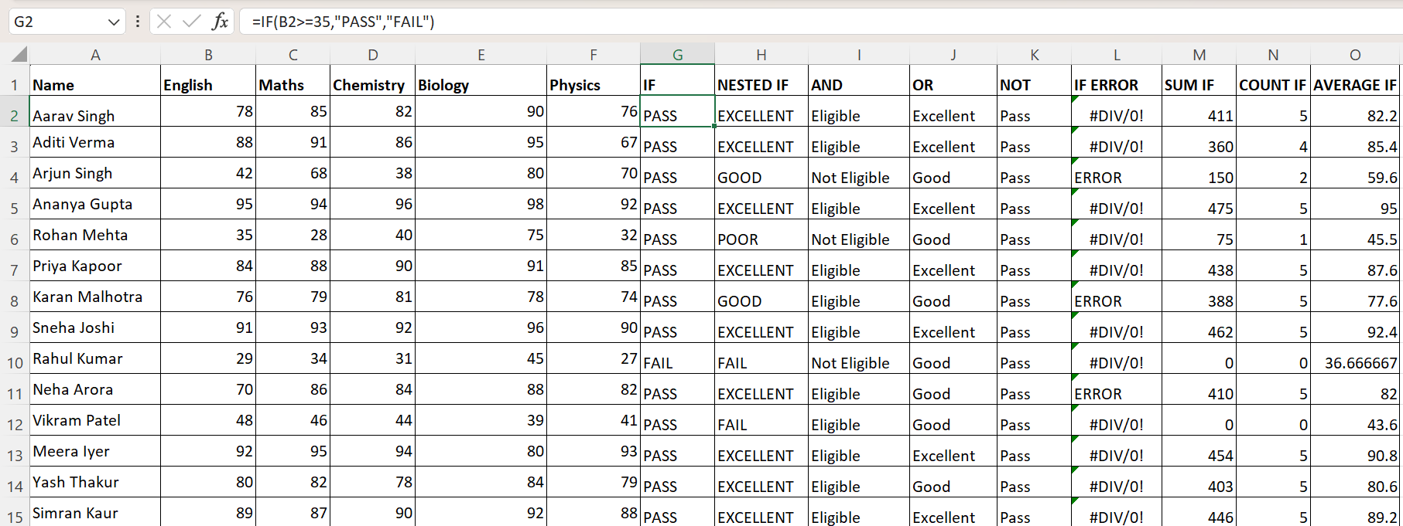
NESTEDIF FORMULA:
Definition:
A Nested IF function contains multiple IF statements to evaluate several conditions in sequence.
Condition: Condition based on marks:
- 80 or above → Excellent
- 79-60 → Good
- 59-50 → Average
- Below 30 → Fail
Formula:
=IF(C2>=80,"EXCELLENT",IF(C2>=60,"GOOD",IF(C2>=50,"AVERAGE",IF(C2>=30,"FAIL","POOR"))))
OUTPUT
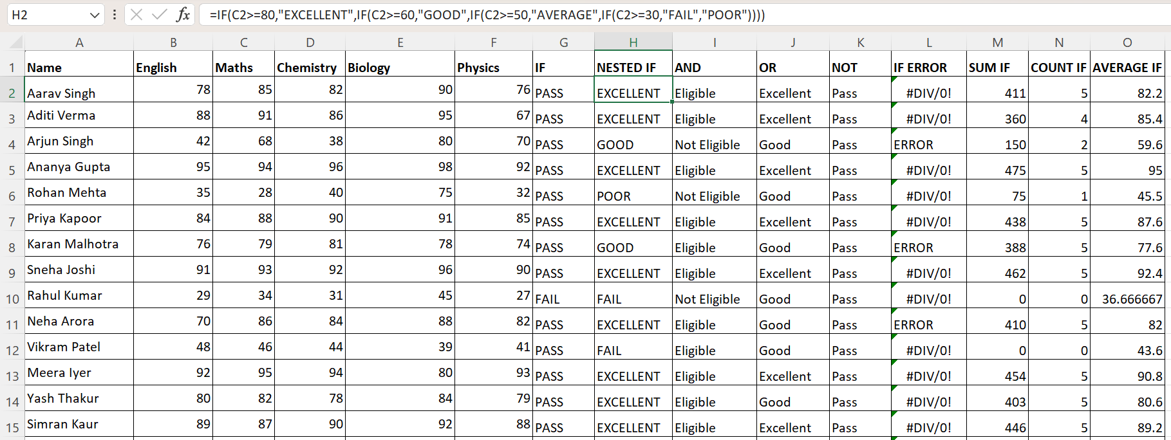

Sukhleen Kaur (25MCA20031)
25MCA-6 (B)

AND FORMULA:
Definition:
The AND function returns TRUE only if all specified conditions are TRUE.
Condition: Marks in Maths and Chemistry more than 40.
Formula: =IF(AND(C2>=40,D2>=40),"Eligible","Not Eligible")
OUTPUT
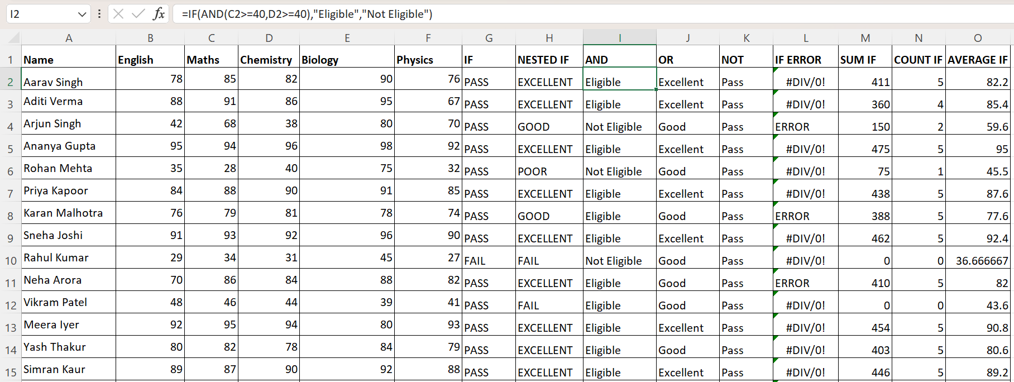
OR FORMULA:
Definition: The OR function returns TRUE if at least one of the specified conditions is TRUE.
Condition: Marks in Biology or Physics should more than 90.
Formula: =IF(OR(E2>=90,F2>=90),"Excellent","Good")
OUTPUT
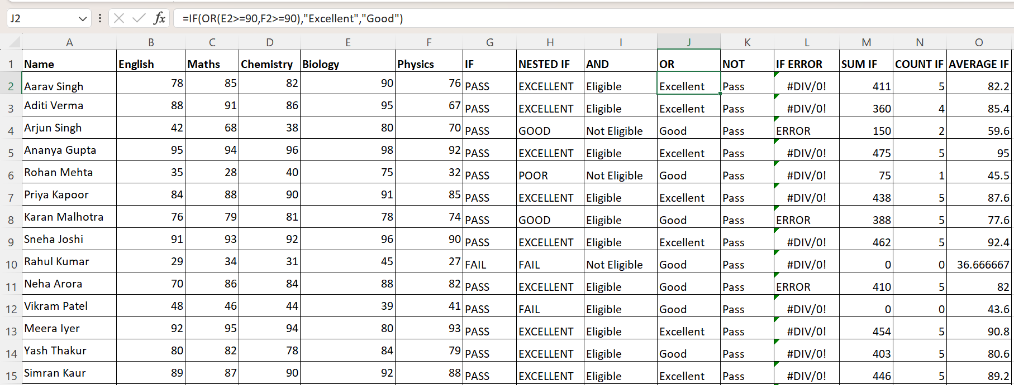
Sukhleen Kaur (25MCA20031)
25MCA-6 (B)
ERRORIF FORMULA:
Definition: The IFERROR function returns a specified value if a formula results in an error; otherwise, it returns the formula result.
Condition: If D2 ÷ 0 is TRUE (i.e., no error occurs), display ERROR otherwise, display NO ERROR.
Formula: =IF(D2/0,"ERROR","NO ERROR")
OUTPUT
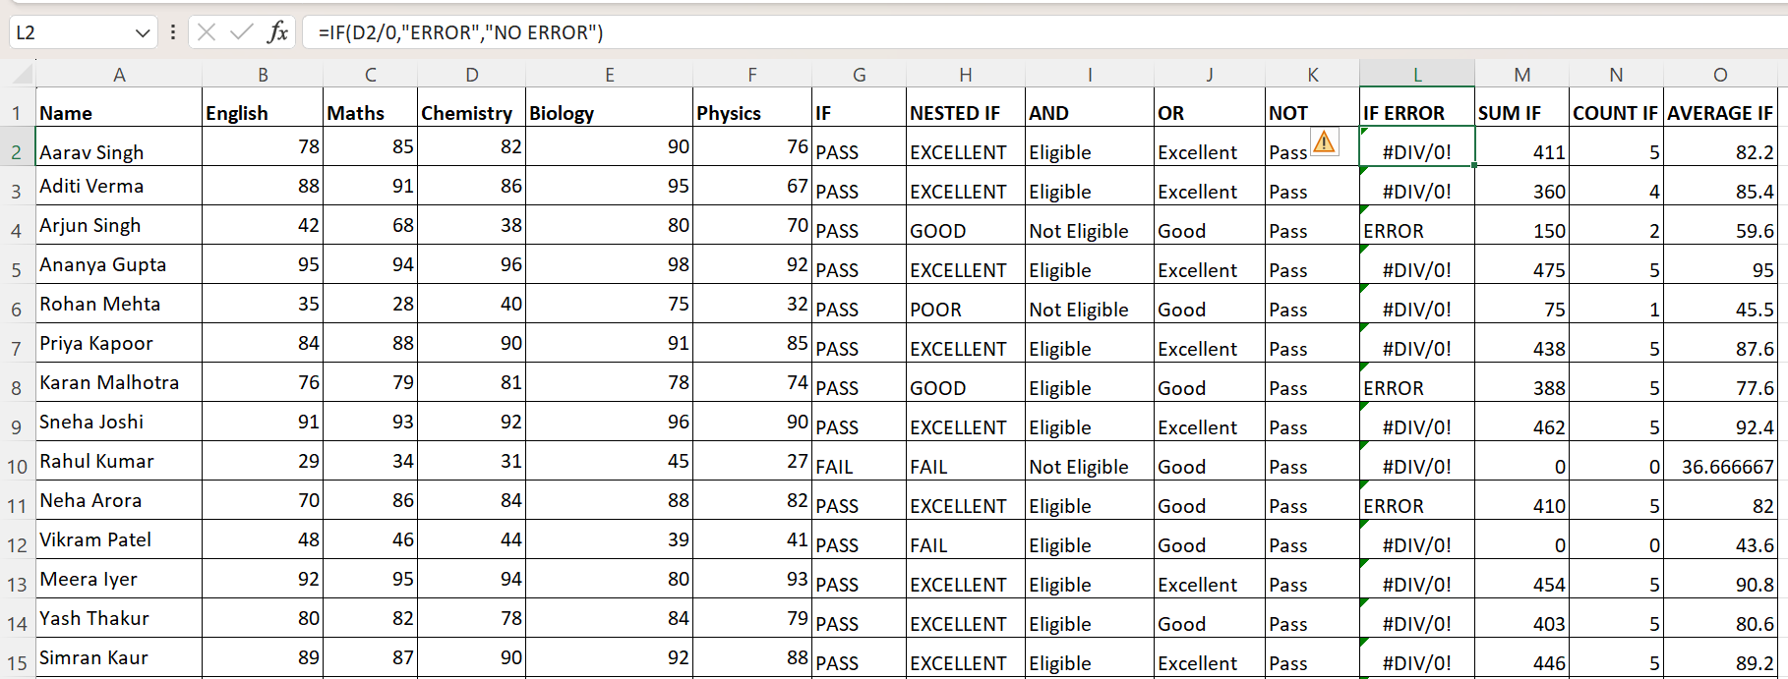
SUMIF FORMULA:
Definition: The SUMIF function adds only those values that satisfy a specified condition.
Condition: Add the marks of all subjects that are greater than or equal to 70.
Formula: =SUMIF(B2:F2,">=70",B2:F2)
OUTPUT
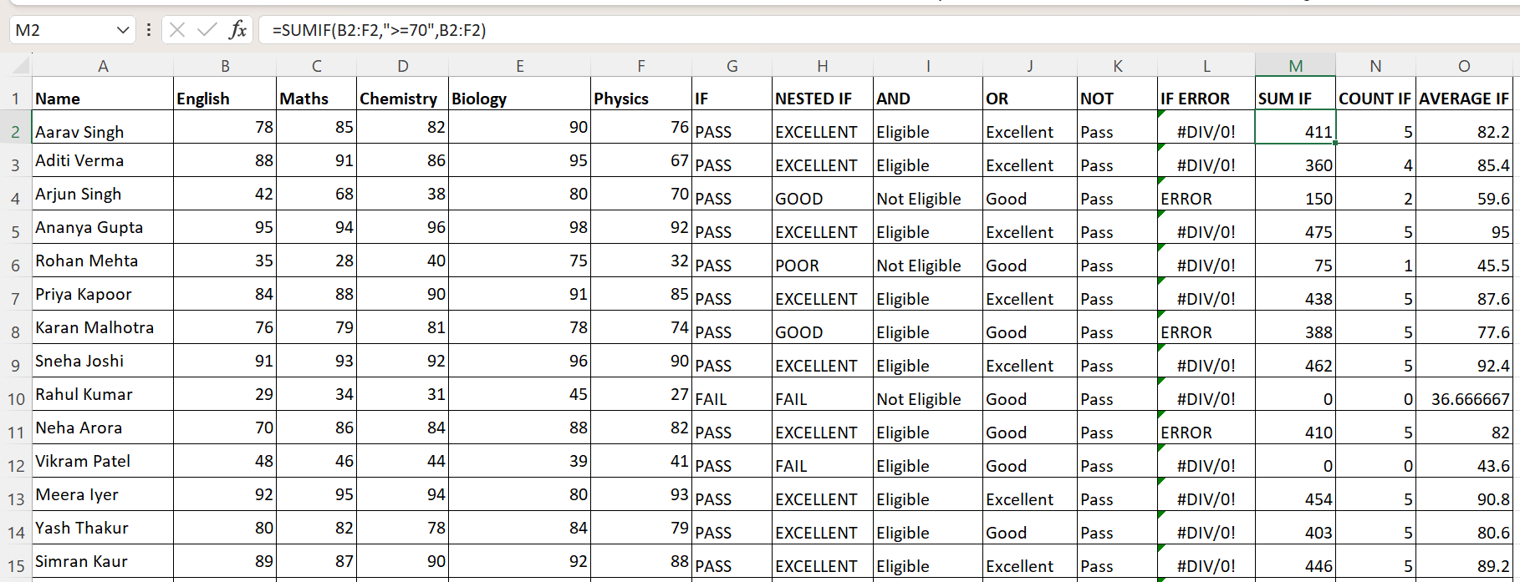
Sukhleen Kaur (25MCA20031)
25MCA-6 (B)

COUNTIF FORMULA:
Definition: The COUNTIF function counts the number of cells that meet a specified condition.
Condition: Count the number of subjects in which the marks are greater than or equal to 70.
Formula: =COUNTIF(B2:F2,">=70")
OUTPUT
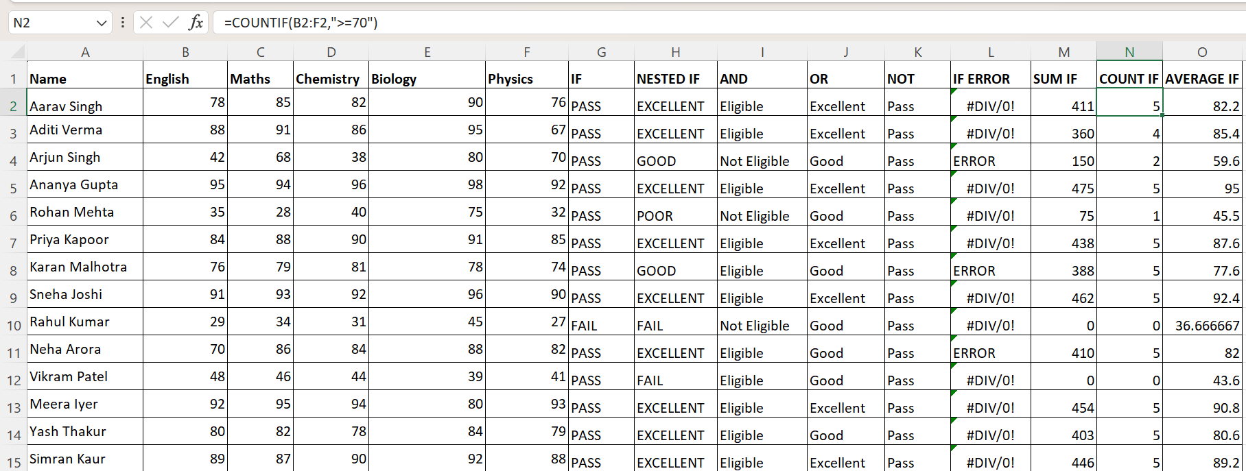
AVERAGEIF FORMULA:
Definition: The AVERAGEIF function calculates the average of values that meet a specified condition.
Condition: Calculate the average of the subject marks that are greater than 30.
Formula: =AVERAGEIF(B2:F2,">=30",B2:F2)
OUTPUT
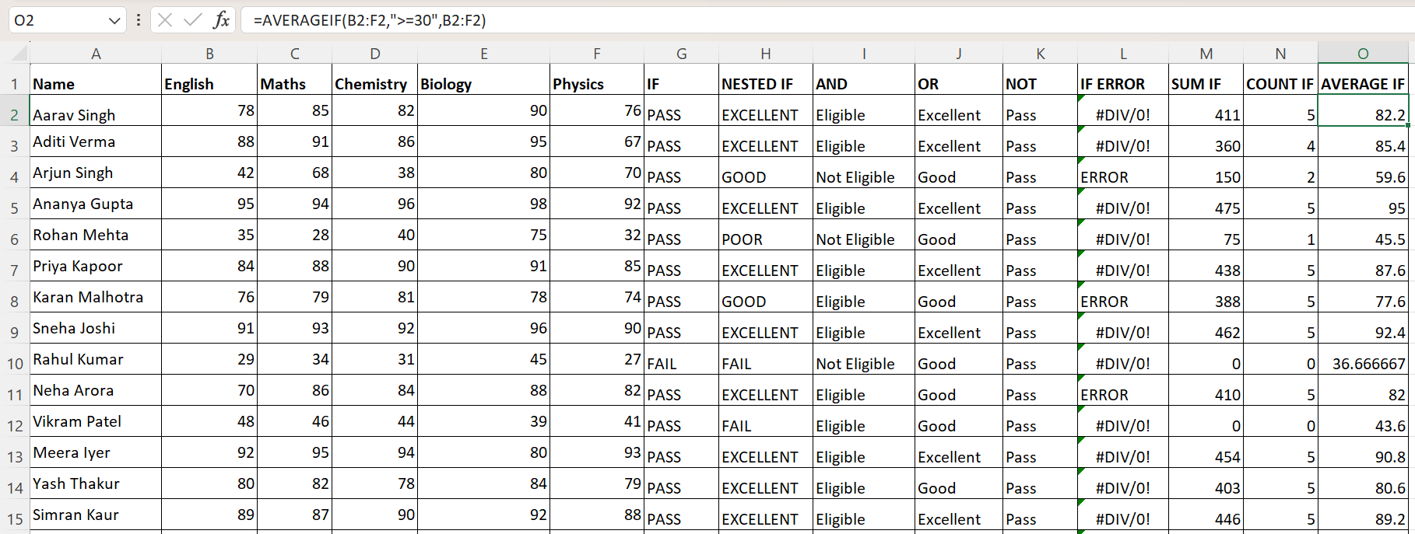
Sukhleen Kaur (25MCA20031)
25MCA-6 (B)

Learning outcomes (What I have learnt):
- Used logical formulas such as IF and Nested IF to perform conditional decision-making.
- Used AND, OR, and NOT functions to evaluate multiple logical conditions.
- Used formula for errors for effectively using the IFERROR function.
- Used conditional calculations using SUMIF, AVERAGEIF, and COUNTIF functions.

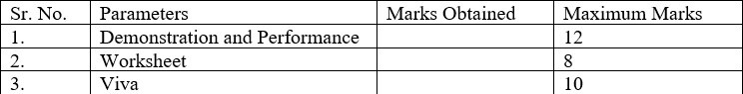
Evaluation Grid:

